**<Understanding the Problem>**

This program has to pass seven fundament steps. The first step is that the program has to shuffle the card. The second step is that the program is giving 7 cards to each player. The third step is that the program has to allow the user and the computer to take the cards which matches to the rank which both player and computer asked by tracking the number of cards which the players have. The fourth step is that the program has to allow the player and the computer to draw one card from the top of the deck if the rank doesn’t match with the rank which the opponent has by tracking the number of cards which the players have. The fifth step is that the program has to book the four cards which has same rank. The sixth step is that the program has to process the game until there is no card on the deck, and calculate who is the winner. The final step is that the program is repeating the game unless the user wants to quit.

To be specific, the player and the opponent (the computer) is playing a game. At first, the program will shuffle the deck and distribute 7 cards to each player. After the card distribution, the opponent will ask you the rank which the opponent has. Then if the player doesn’t have a rank that the opponent asked, the opponent have to draw one card from the top of the deck. However, if the player has a rank which the opponent asked, then the player has to give all of the card which has the rank the opponent asked. If the opponent made it to take the card from the player, the opponent can do this process until the opponent fails to take cards from the player. If there are four cards which have same rank and different suit, the opponent can book them. These works same to the player. The game processes until there is no card from the deck. When there is no card on the deck, the winner will be a participant who has the most booked card. The program will iterate the game infinitely unless the player wants to quit the game.

**<Assumptions>**

I assume that the players cannot deceive each other. For instance, the player can’t say ‘go fish’ even if the player has a rank 2 which is the rank that opponent is asking.

I assume that there will have no tie game in the go fish game.

I assume that the players will have to give all the cards which has a rank that the opponent is asking.

**<Program Design>**

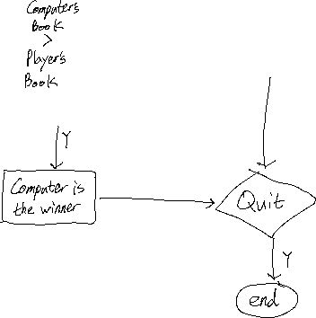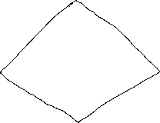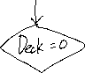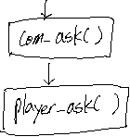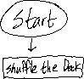

**<com_ask()>**

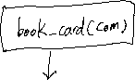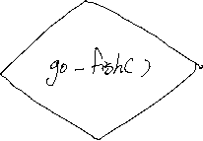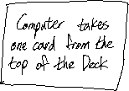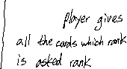

**<book_card(player p)>**

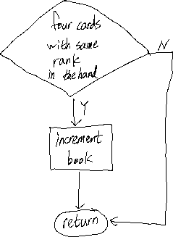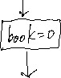

**<player_ask()>**

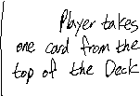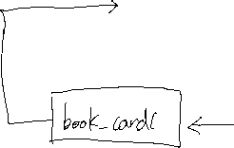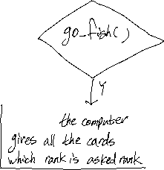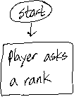

**<go_fish(player p1,player p2)>**

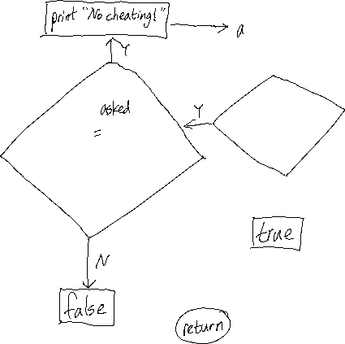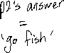

**<Program Testing>**

|  |  |  |
| --- | --- | --- |
| **Setting** | **Input** | **Expected Result** |
| <Case 1> | Go fish! | Print “No Cheating!” |
| <Case 1> | 7 | The computer takes the card which rank is 7 from the player. |
| <Case 2> | A | If the computer has ‘A’)  Take the cards which rank is ‘A’ from the computer |
| <Case 2> | A | If the computer hasn’t ‘A’)  <Computer: go fish>  Take one card from the top of the deck. |
| <Case 3> | n | The program stats the game again. |
| <Case 3> | y | End the program. |

D: diamonds, C: clubs, H: hearts, S: spades / (suit of the card, rank of the card)

<Case 1>

Computer: ___ ___ ___ ___ ___ ___ ___

Computer asks 7

Player: (D, A) (C,2), (H,3), (S,4), (D,5), (H,6), (H,7)

Your Choice:

Booked: Computer: 0 | Player: 0

<Case 2>

Computer: ___ ___ ___ ___ ___ ___ ___ ___

Player: (D, A) (C,2), (H,3), (S,4), (D,5), (H,6), (H,7)

You can ask A 2 3 4 5 6 7:

<Case 3>

Computer:

Player:

Booked: Computer: 6 | Player: 7

You are the winner! Do you want to quit the game? (y/n)